Database Documentation

Create a Database

- In your integrated development environment (IDE), create a database schema called QuantigrationRMA. List out the database name. Provide the SQL commands you ran to successfully complete this in your answer, then connect to it:

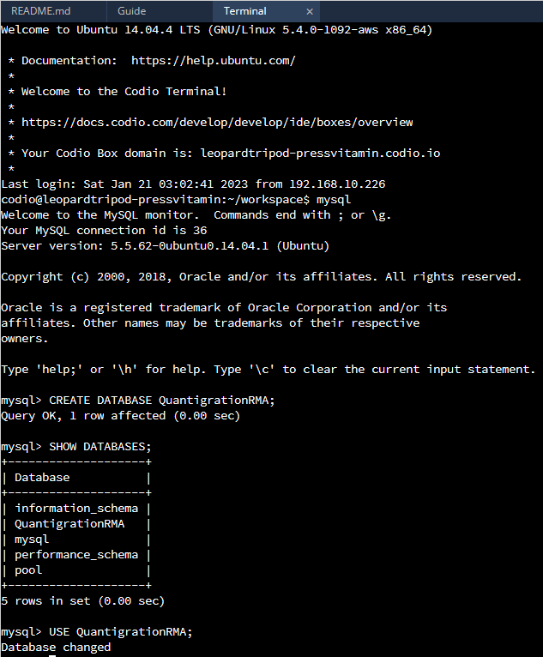
CREATE DATABASE QuantigrationRMA;
SHOW DATABASES;
USE QuantigrationRMA;

- Using the entity relationship diagram (ERD) as a reference, create the following tables with the appropriate attributes and keys:

  - A table named customers in the QuantigrationRMA database as defined on the project ERD. Provide the SQL commands you ran against MySQL to complete this successfully in your answer:

CREATE TABLE Customers (
CustomerID INT PRIMARY KEY,
FirstName VARCHAR(25),
LastName VARCHAR(25),
Street VARCHAR(50),
City VARCHAR(50),
State VARCHAR(25),
ZipCode INT,
Telephone VARCHAR(15)
);

  - A table named orders in the QuantigrationRMA database as defined on the project ERD. Provide the SQL commands you ran against MySQL to complete this successfully in your answer:

CREATE TABLE Orders (
OrderID INT PRIMARY KEY,
CustomerID INT,
FOREIGN KEY (CustomerID) REFERENCES Customers(CustomerID),
SKU VARCHAR(20),
Description VARCHAR(50)
);

  - A table named rma in the QuantigrationRMA database as defined on the project ERD. Provide the SQL commands you ran against MySQL to complete this successfully in your answer:

CREATE TABLE RMA (
RMAID INT PRIMARY KEY,
OrderID INT,
FOREIGN KEY(OrderID) REFERENCES Orders(OrderID),
Step VARCHAR(50),
Status VARCHAR(15),
Reason VARCHAR(15)
);

screenshots on next page
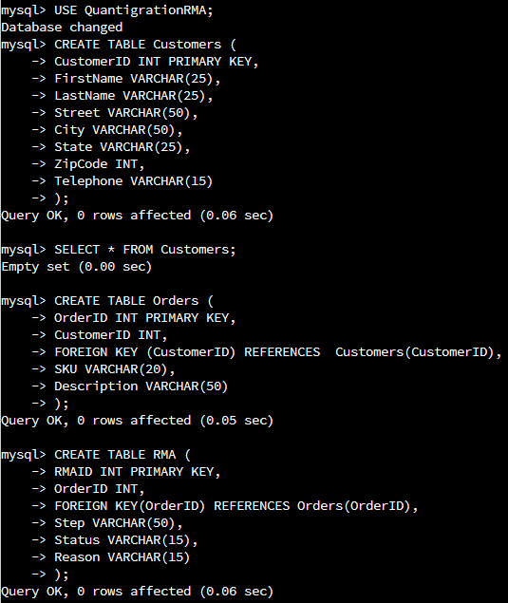

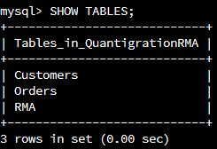

- Manually add 10 records into the Customers table. The data can be made up for now, as you you’ll populate all three tables later from the provided CSV files.

INSERT INTO Customers VALUES
(100, ‘Matthew’, ‘Pool’, ‘333 West World St.’, ’Dallas’, ‘TX’, 75601, ‘903-903-9033’);

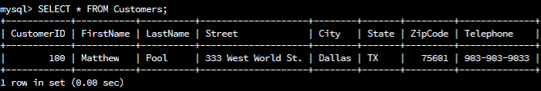
SELECT * FROM Customers;

(101, ‘Billie’, ‘Eilish’, ‘666 Beetlejuice Blvd.’, ‘Austin’, ‘TX’, 75602, ‘855-855-8855’);

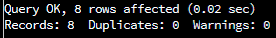
INSERT INTO Customers VALUES
(102, ‘Martha’, ‘Magoo’, ‘777 7th St.’, ‘San Antonio’, ‘TX’, 75603, ‘999-999-9999’),
(103, ‘Bobbie’, ‘Brown’, ‘888 8th St.’, ‘Houston’, ‘TX’, 75604, ‘333-333-3333’),
(104, ‘Chester’, ‘Chesterson’, ‘West Lake Dr.’, ‘Los Angeles’, ‘CA’, 75605, ‘444-444-4444’),
(105, ‘Tyler’, ‘Blevins’, ‘Nintendo Ave.’, ‘Palm Springs’, ‘FL’, 75606, ‘555-555-5555’),
(106, ‘Sypher’, ‘PK’, ‘Epic Ln.’, ‘Hollywood’, ‘CA’, 75607, ‘666-666-6666’),
(107, ‘Kurtis’, ‘Commander’, ‘420 Heart-Shaped Ln.’, ‘Seattle’, ‘WA’, 75608, ‘777-777-7777’),
(108, ‘Adam Jack’, ‘Ryan’, ‘ 1101 Symphony Ln.’, ‘Music Town’, ‘CA’, 75609, ‘666-999-6969’),
(109, ‘Oliver’, ‘Tree’, ’99 Problems Blvd.’, ‘Bodunk’, ‘TX’, 75610, ‘222-222-2222’);
- You’ve been asked to establish a database view called "Collaborators" that is based on the "Customers" table. Create a view from the existing Customers table by using the SQL command provided below to say "Collaborators." The view should show all instances of "Customer" renamed as "Collaborator." Execute the following statements and provide one or more supporting screenshots showing the database view:
  - The following command is partially complete. Fill in the missing information in the brackets to complete it and run the commands correctly:
    - CREATE VIEW Collaborator AS
SELECT CustomerID AS CollaboratorID, [Enter in the correct column names from that customer table that you want to change in the collaborator table]
FROM Customers;
  - DESCRIBE Collaborator;
  - SELECT * FROM Collaborator LIMIT 5;
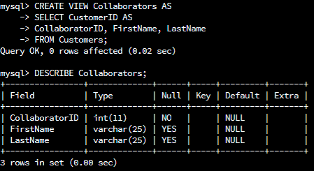
CREATE VIEW Collaborators AS
SELECT CustomerID AS
CollaboratorID, FirstName, LastName
FROM Customers;

DESCRIBE Collaborators;

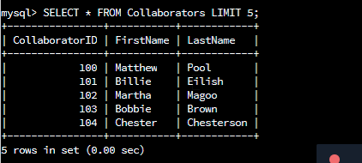
SELECT * FROM Collaborators LIMIT 5;

